Full Stack Development with MERN
PROJECT DOCUMENTATION
Implement Client Script & UI Policy (Incident)
Team ID | SWTID-2026-9505
Date | 3 OCTOBER 2026
Platform | ServiceNow

1. Introduction
Project Title: Implement Client Script & UI Policy (Incident)
Team ID: SWTID-2026-9505
Team Members:
Team member | Role / responsibility
Venthan B | Created the UI Policy (High Impact Control) and the UI Policy Action for the Urgency field; wrote the project conclusion
Sajeevatharan S | Created the onChange Client Script (auto set urgency) and the onSubmit Client Script (Assigned To validation)
Jeeva S | Created the onCellEdit Client Script (prevent State change via list edit)
Rohith G | Testing – successful save and reverse condition tests
Rakesh K | Testing – list edit blocking and form-based update tests

2. Project Overview
Purpose
The purpose of this project is to keep Incident data in ServiceNow clean, consistent and reliable by applying client-side controls on the Incident form and list. The project uses a UI Policy together with Client Scripts to automate field behaviour, enforce mandatory data when it matters, and block incorrect updates before they are saved.
Features
- UI Policy "High Impact Control" on the Incident table, triggered when Impact is 1 - High.
- UI Policy Action that makes the Urgency field read-only for high-impact incidents, with Reverse if false enabled.
- onChange Client Script that automatically sets Urgency to High when Impact is set to High and shows an information message.
- onSubmit Client Script that stops the save and shows an error when Impact is High and Assigned To is empty.
- onCellEdit Client Script that blocks changes to the State field from the list view and shows an alert.
- State can still be updated from the Incident form.

3. Architecture
Note: this project is a ServiceNow configuration project, not a MERN-stack application. The three architecture parts of the template are therefore described using the ServiceNow equivalents.

Frontend
There is no React frontend. The user interface is the standard ServiceNow Incident form and Incident list. Behaviour is added on the client side through a UI Policy (with a UI Policy Action) and three Client Scripts written in JavaScript using the g_form API: onChange, onSubmit and onCellEdit.

Backend
There is no Node.js / Express.js backend. Request handling, form processing and record saving are done by the ServiceNow platform itself. No custom server-side code was written in this project.

Database
There is no MongoDB database. Records are stored in the ServiceNow platform database in the Incident [incident] table. The project does not change the table structure; it only reads and controls the following fields:
Field (name) | Type | Use in this project
Impact (impact) | Choice | Trigger for the UI Policy and onChange script; value 1 = High
Urgency (urgency) | Choice | Set to 1 (High) automatically and made read-only for high impact
Assigned to (assigned_to) | Reference (User) | Must be filled before saving a High-impact incident
State (state) | Choice | Cannot be changed through list editing; editable on the form

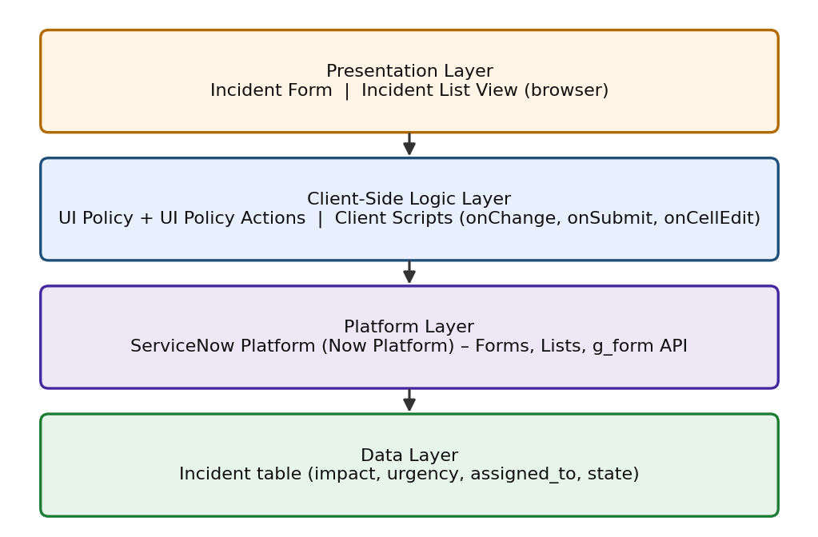
Figure 1: Layered architecture of the solution

4. Setup Instructions

Prerequisites
- A ServiceNow instance (for example a Personal Developer Instance) with administrative or configuration access.
- A modern web browser such as Chrome or Edge.
- A user account with admin rights to open System UI > UI Policies and System UI > Client Scripts.
- Node.js and MongoDB are not required for this project.

Installation
There is nothing to clone or install with npm. The solution is set up by creating the following records inside the ServiceNow instance:
- Log in to the ServiceNow instance as an administrator.
- Go to System UI > UI Policies and click New. Create "High Impact Control" on the Incident table with condition Impact is 1 - High and Reverse if false set to true. Submit.
- Open the UI Policy and, in the UI Policy Actions related list, click New. Select the Urgency field, set Read-only to true, and Submit.
- Go to System UI > Client Scripts and create "Auto set urgency for high impact": Table = Incident, Type = onChange, Field name = Impact, Active = true. Paste the onChange script from the Appendix and Submit.
- Create "Prevent save if Assigned To missing": Table = Incident, Type = onSubmit, Active = true. Paste the onSubmit script and Submit.
- Create "Prevent state change via list edit": Table = Incident, Type = onCellEdit, Field name = State, Active = true. Paste the onCellEdit script and Submit.
Environment variables are not used in this project.

5. Folder Structure
There are no client and server folders in this project because the work is configuration inside ServiceNow. The equivalent organisation is shown below.

Client
Location in ServiceNow | Record
System UI > UI Policies | High Impact Control (with its UI Policy Action on Urgency)
System UI > Client Scripts | Auto set urgency for high impact (onChange)
System UI > Client Scripts | Prevent save if Assigned To missing (onSubmit)
System UI > Client Scripts | Prevent state change via list edit (onCellEdit)

Server
No server-side scripts, Business Rules or custom APIs were created. All server processing is the standard ServiceNow platform behaviour for the Incident table.

6. Running the Application
There are no frontend or backend servers to start (no npm start). Once the records are saved and active, the configuration runs automatically on the ServiceNow instance. To use it:
- Log in to the ServiceNow instance.
- Go to Incident > Create New (or open an existing incident) to use the Incident form.
- Go to Incident > All to use the Incident list view, where the State edit restriction applies.

7. API Documentation
This project does not expose any REST endpoints or custom APIs, so there are no request methods, parameters or response bodies to document. The scripts call the built-in ServiceNow client-side g_form API, summarised below.
Method | Used for | Used in
g_form.getValue(field) | Read the current value of Impact or Assigned to | onSubmit
g_form.setValue(field, value) | Set Urgency to 1 (High) | onChange
g_form.addInfoMessage(msg) | Show an information message on the form | onChange
g_form.showErrorBox(field, msg) | Show an error on the Assigned to field | onSubmit
callback(false) | Cancel the cell edit in the list | onCellEdit

Example response (message shown to the user when saving a High-impact incident with no assignee):
Assigned To is mandatory for High Impact incidents.

8. Authentication
The project does not implement its own authentication or authorization. Users log in to the ServiceNow instance through the platform's standard login, and the platform manages the user session and access rights. The configuration in this project is built by an administrator and then applies to the Incident form and list for users who open them. No custom tokens, JWT or session handling were added.

9. User Interface
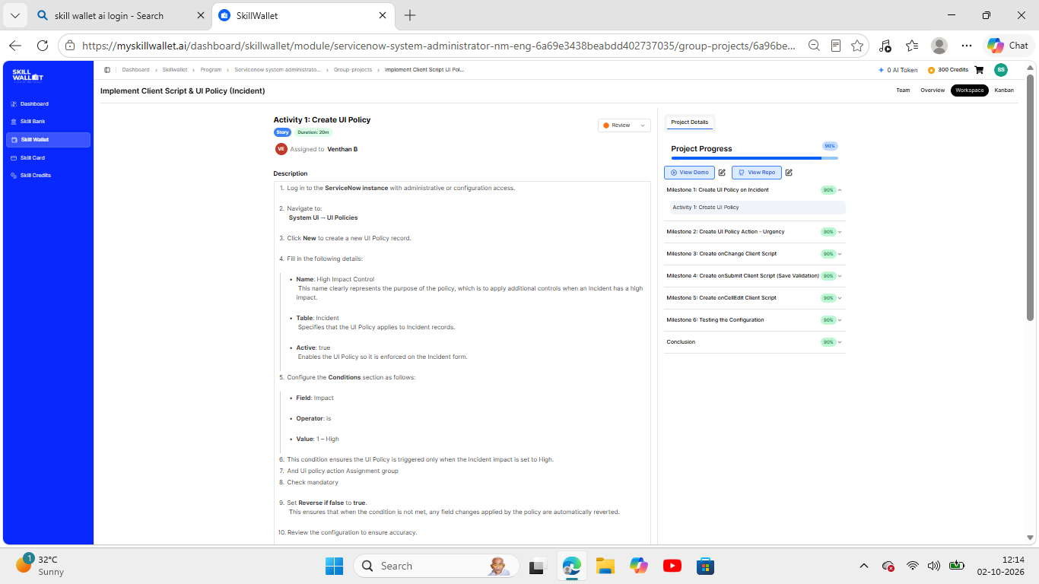
Figure 2: Creating the UI Policy (High Impact Control)
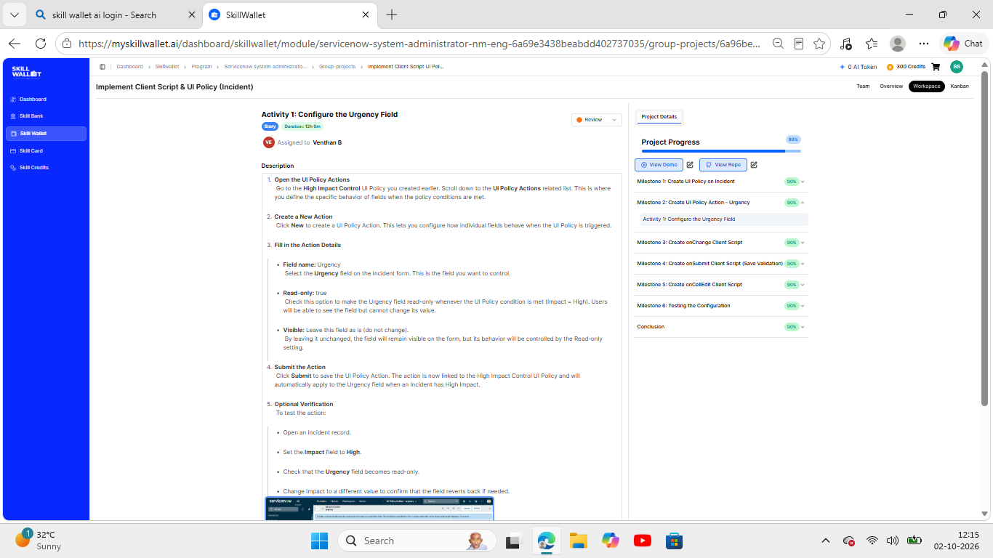
Figure 3: UI Policy Action for the Urgency field
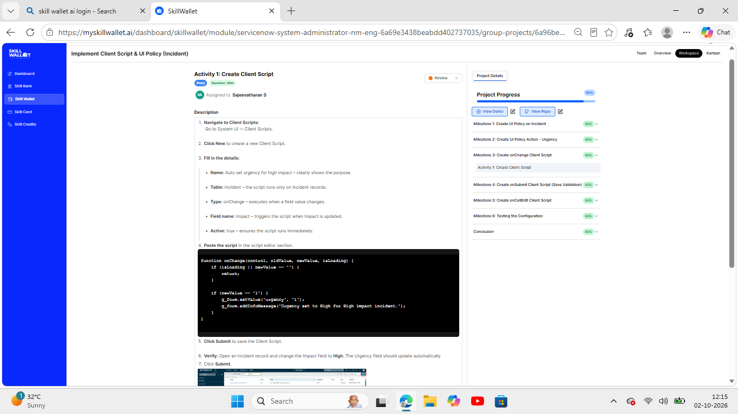
Figure 4: onChange Client Script (auto set urgency)
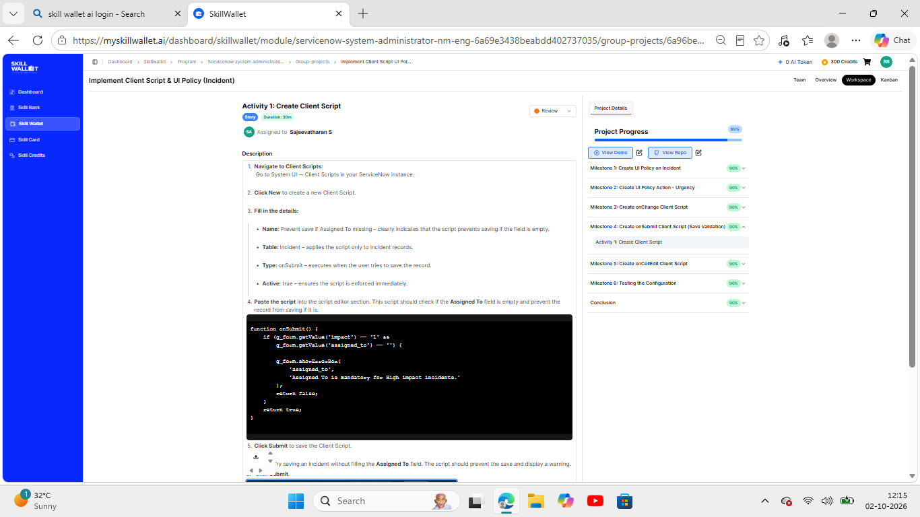
Figure 5: onSubmit Client Script (Assigned To validation)
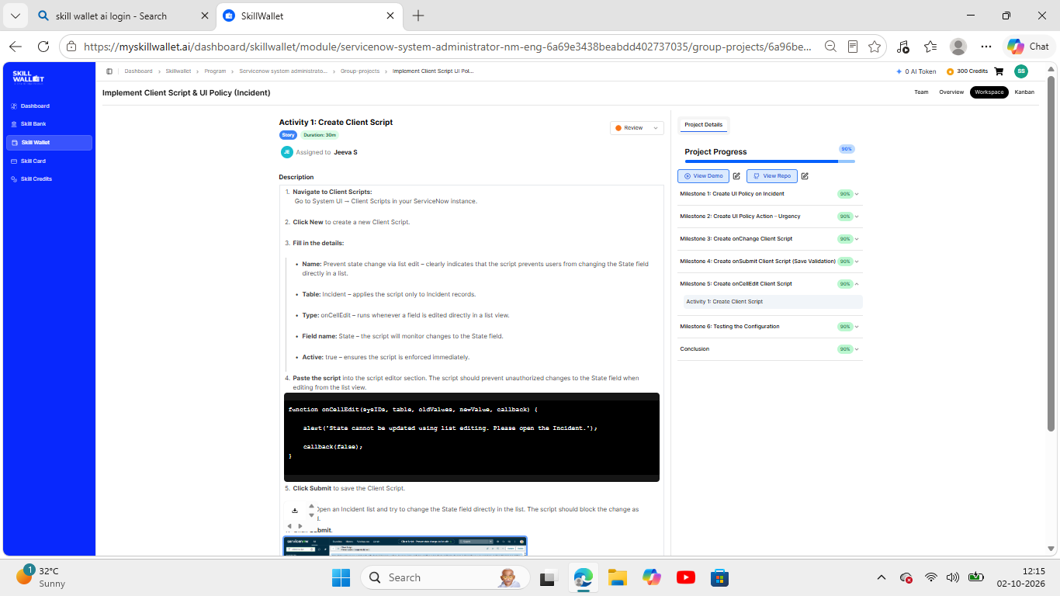
Figure 6: onCellEdit Client Script (block State edit in list)

10. Testing
Testing strategy: manual functional testing on the ServiceNow Incident form and list view, carried out in Milestone 6 of the project. Each test compares the expected behaviour with what is observed in the instance. No automated testing tools were used.
ID | Test case | Steps | Expected result | Result
TC-1 | Mandatory enforcement | Open a new Incident, set Impact = High, leave Assigned To empty, click Submit | Save is blocked and an error is shown on Assigned To | Pass
TC-2 | Successful save | Select a user in Assigned To and click Submit | Incident saves; Urgency auto-set and read-only; list restriction still active | Pass
TC-3 | Reverse condition | Open a High-impact incident, change Impact to Medium, click Update | Assigned To not mandatory; Urgency editable again; save succeeds | Pass
TC-4 | List edit blocking | In the Incident list, double-click the State field and try to edit | Alert shown; State value unchanged | Pass
TC-5 | Form-based update | Open the Incident form, change State, click Update | State saves successfully; other rules continue to work | Pass

11. Screenshots or Demo
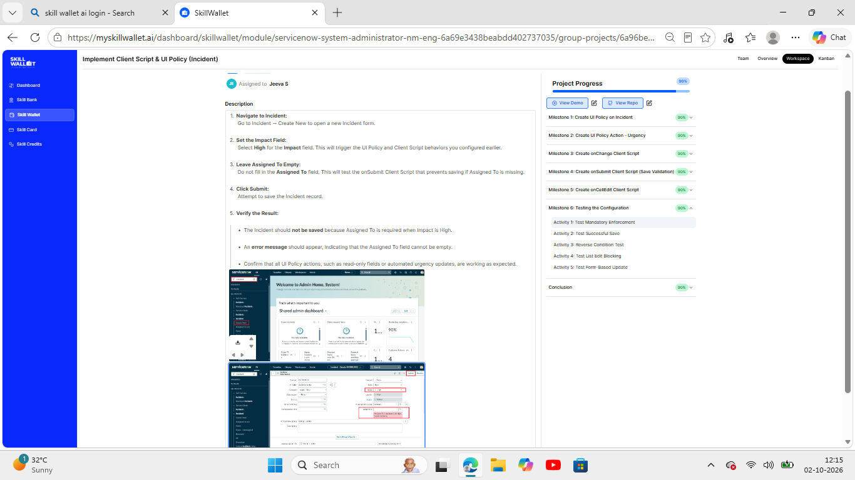
Figure 7: Test 1 – Mandatory enforcement
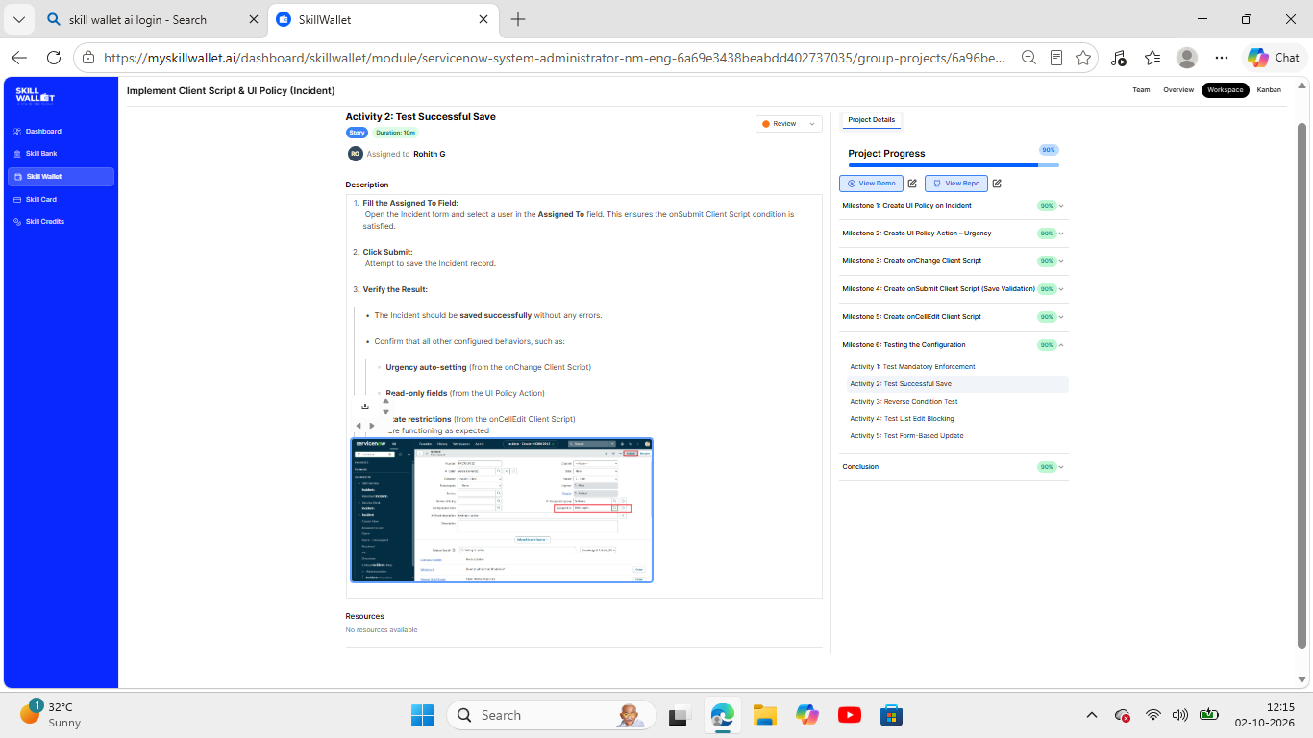
Figure 8: Test 2 – Successful save
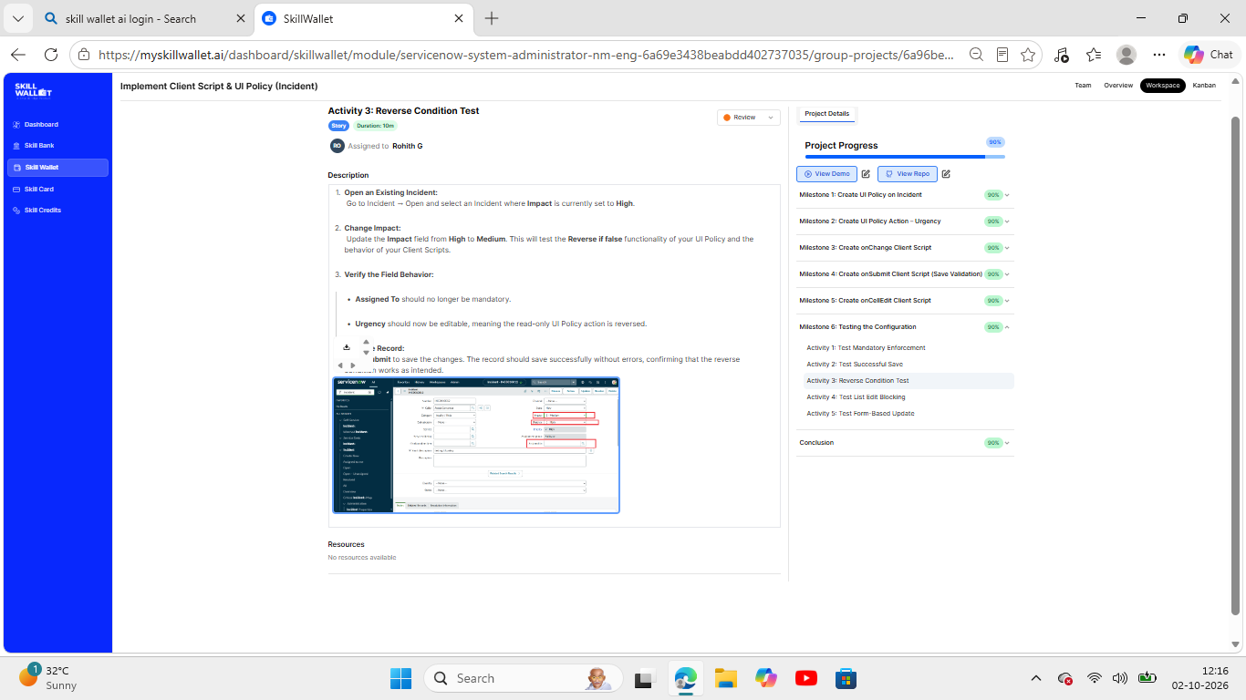
Figure 9: Test 3 – Reverse condition
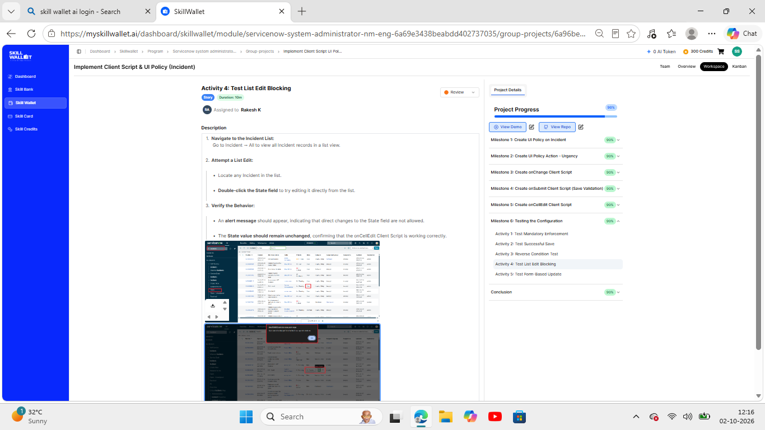
Figure 10: Test 4 – List edit blocking
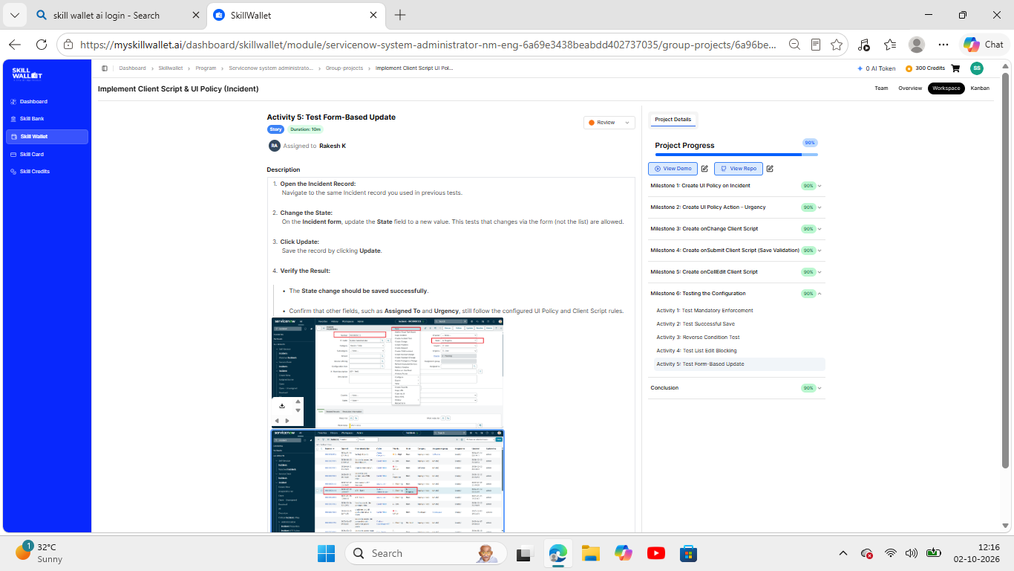
Figure 11: Test 5 – Form-based update
Demo link: [add your demo link here]

12. Known Issues
- Client-side rules can be bypassed by imports, integrations or API calls because no server-side validation was added.
- The onCellEdit script blocks State edits in the list for all users, regardless of role.
- The rules apply on the standard UI; other interfaces (such as a portal or mobile app) may need separate checks.
- The Assigned To check relies on the Impact value 1 (High); if the choice values are changed, the scripts must be updated.

13. Future Enhancements
- Add server-side Business Rules or Data Policies so the same rules apply to imports and integrations.
- Make the list-edit restriction role-based.
- Extend the controls to Priority, Category and Assignment Group.
- Send automatic notifications to the assignment group for High-impact incidents.
- Apply the same approach to Problem, Change and Service Request tables.

Appendix: Source Code
onChange – Auto set urgency for high impact
function onChange(control, oldValue, newValue, isLoading) {
if (isLoading || newValue === '') {
return;
}

if (newValue == '1') {
g_form.setValue('urgency', '1');
g_form.addInfoMessage('Urgency set to High for High impact incident.');
}
}

onSubmit – Prevent save if Assigned To is missing
function onSubmit() {
if (g_form.getValue('impact') == '1' &&
g_form.getValue('assigned_to') == '') {
g_form.showErrorBox(
'assigned_to',
'Assigned To is mandatory for High Impact incidents.'
);
return false;
}
return true;
}

onCellEdit – Prevent state change via list edit
function onCellEdit(sysIDs, table, oldValues, newValue, callback) {
alert('State cannot be updated using list editing. Please open the Incident.');
callback(false);
}

